**Image sampling and quantization - Assignment 2**

# Spatial Resolution

Spatial resolution is the number of pixels in the image. Images with more pixels have a higher spatial resolution than images with a smaller number of pixels. To test the impact of spatial resolution, we obtained three images of the same object. Each image was a different size and therefore contained different amounts of pixels. Inspecting and comparing each image should reveal qualitative differences that could be observed at various levels of magnification. Our goal was to observe the effect of pixel count differences by reviewing color, edges, clarity, crispness and other metrics that would affect an image's overall quality. Our analysis proved that images of a higher spatial resolution were of a higher clarity, had cleaner lines, contained better color detail and were upon close inspection, of better quality.

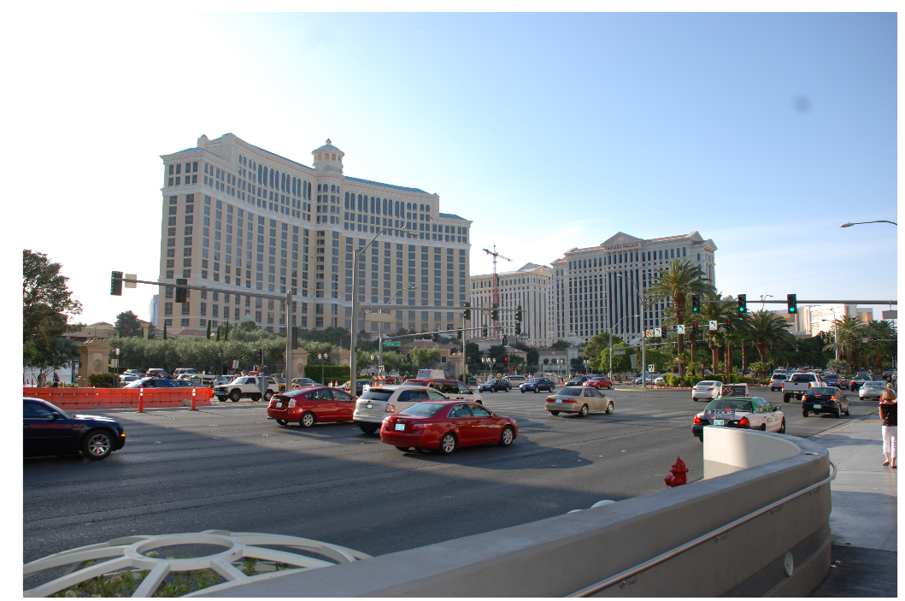

Original Image

Image 1:

Pixel Count = 10036224

Size = 3872x2592

Image 2:

Pixel Count = 2509056

Image Size = 1936x1296

Image 3:

Pixel Count = 627264

Image Size = 968x648

Qualitative Assessment:

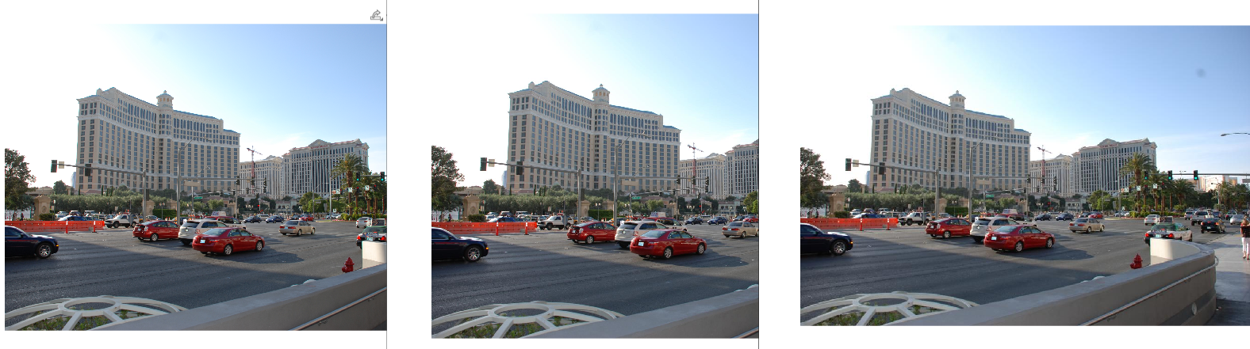

Figure 1- image 1 (left), image 2 (middle) and image 3 (right)

In a general inspection, the three images in Figure 1 (image 1 (left image), image 2 (middle image) and image 3 (right)), appear to be identical. Large objects with less detail appear to be clear, small objects and objects with more detail appear to be pixelated and unclear.

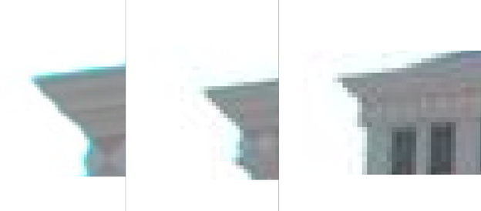

Figure 2 - image 1 (left), image 2 (middle) and image 3 (right)

However, in a closer inspection per Figure 2, the differences are dramatic. A closer view of the buildings upper edge in image 1 (left image), image 2 (middle image) and image 3 (right) shows that image 1 contains more pixels and therefore more detail than image 2 or image 3. The edges in image 1 also appear to be smoother and the color and lines are better defined. The smoothing and definition can be attributed to the smaller size of each pixel and the larger number of total pixels. An image with more pixels would likely present a better picture.

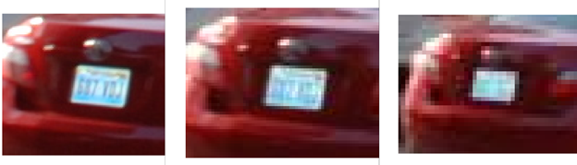

Figure 3 - image 1 (left), image 2 (middle) and image 3 (right)

Significant differences in the pixel count in each image also make a qualitative difference in the readability or clarity in the image. For example, see Figure 3, Image 1 (left), Image 2(middle), Image 3 (right). In image 1, smaller pixel sizes with a higher pixel count present a clearer image with better detail. In this image of a license plate of a red car, the viewer is able to identify some, or all of the license plate numbers. In Image 2, the license plate number is too pixelated to read however the user could potentially identify that it is a license plate or contains some type of writing. Edges are too jagged to properly display the numbers. In Image 3, the user would be unable to decipher what was in the image, including the letters on the license plate or the type of car in the picture.

**Intensity Resolution**

Intensity Resolution can be measured in DPI or dots per inch. When we talk about a high-resolution picture we are talking about a large number of dots (or pixels) per inch that adds to the image. By altering the intensity of an image, we essentially are reducing the number of dots per inch on that image. In turn, losing clarity and sharpness in the image. Using the following images below we can see how altering the value of K or intensity level affects the image.

Our original image, or Intensity value of 2^8

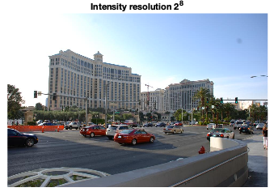

From here we will reduce the intensity level by 2 at each step.

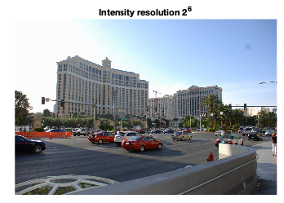

Altering the value of k to 6 does not seem to affect the image too drastically to the naked eye.

But when we change the value of k to 4 we begin to see the image lose its sharpness and crispness. The loss of pixels per inch are clearly visible in the blue-sky background. One can see the colors in the sky not blend in but stand out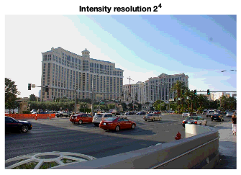

as different layers even though that is not the case in real life.

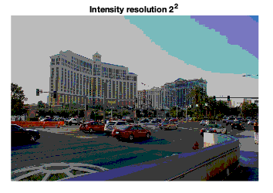

Lastly, when we reach k value of 2, we can clearly tell the image has lost all its sharpness. The sharp reduction in the number of pixels per inch are clearly identifiable.

Greyscale Interpretation of the same image displayed below.

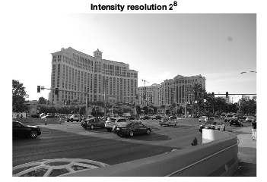 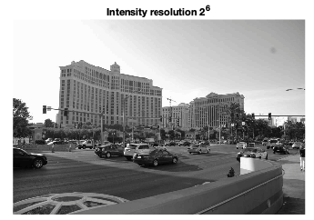

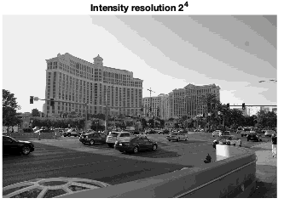

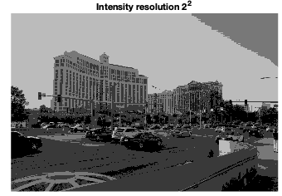

The question of whether a higher spatial resolution would affect the intensity resolution does arise. But as per the below figures we can see that a higher spatial resolution does not affect the intensity resolution greatly of the images.

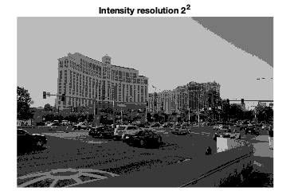

Image of the left is that of the highest spatial resolution from our sample images. Comparing this to the Intensity resolution with k=2 from the sample image with the smallest spatial resolution.



**Image Interpolation**

# A. Nearest Neighbor

This is the simplest and requires the least processing time of all the interpolation algorithms.

Nearest neighbor selects the value of the nearest pixel by rounding the coordinates of the desired interpolation point.

Using this method, one finds the closest corresponding pixel in the source (original) image for each pixel in the destination image. New pixels are made the same as others close-by. The pixels or dots of color are duplicated to create new pixels as the image grows. It creates pixilation or edges that break up curves into steps or jagged edges. This form of interpolation suffers from normally unacceptable effects for both enlarging and reduction of images].

# B. Bilinear Interpolation

Bilinear interpolation takes a weighted average of the four neighborhood pixels to calculate its final interpolated value. The result is much smoother image than the original image. When all known pixel distances are equal, then the interpolated value is simply their sum divided by four. This technique performs interpolation in both directions, horizontal and vertical. This technique gives better result than nearest neighbor interpolation and take less computation time compare to bicubic interpolation.

# C. Bicubic Interpolation

Bicubic goes one step beyond bilinear by considering the closest 4x4 neighborhood of known pixels for a total of 16 pixels.

Since these are at various distances from the unknown pixel, closer pixels are given a higher weighting in the calculation.

Bicubic produces noticeably sharper images than the previous two methods and is perhaps the ideal combination of processing time and output quality. For this reason, it is a standard in many image editing programs including Adobe Photoshop, printer drivers and in-camera interpolation

**Subjective Evaluation**

Image is used is watched by people (our team), so it is more suitable to evaluate the magnified image quality with subjective methods.

**Differences between Original and Nearest neighbor interpolation**.

Nearest-neighbor interpolation, replacing every pixel with a number of pixels of the same color. The resulting image is larger than the original, and preserves all the original detail, but has (possibly undesirable) jaggedness.

In Our case, enlarged image quality was compared from two aspects: subjective and objective.

Nearest neighbor image in our case showed staircase lines when enlarged to the top right of the building with shade of grey. Original image has smooth curves on the other hand nearest neighbor has slight differences specially with jagged edges of building. Other scaling methods below are better at preserving smooth contours in the image.

The major drawback to this algorithm is that, despite its speed and simplicity, it tends to generate images of poor quality. Although the image pattern was up sampled flawlessly, though with little to no noticeable loss of sharpness. The key point here is that this is a simple and fast algorithm. Included below are two more examples that demonstrate the drawbacks of this algorithm.



**Differences between Original and Bilinear/Linear interpolation**.

Linear (or bilinear, in two dimensions) interpolation is typically good for changing the size of an image but causes some undesirable softening of details and can still be somewhat jagged.

In bilinear interpolation algorithm, the position of pixel P in the magnified image was converted into the original image, then the Influence of the four pixel points A, B, C and D was calculated The nearer distance to the point P, the value is greater, which indicates the greater effects

In our case, enlarged image quality was compared from two aspects: subjective and objective.

Bilinear image on zooming fades the pixels and displays a washed-out image of objects.

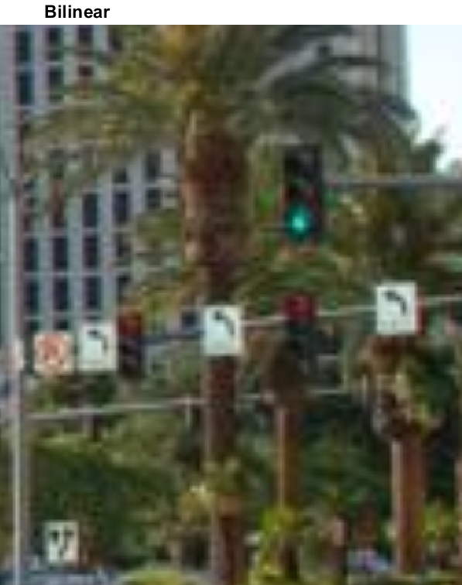

**Differences between Bilinear and Bicubic interpolation**.

Bicubic interpolation is similar to bilinear interpolation algorithm. For the unknown pixel P in an amplified image, its influence sphere is expanded to its 16 adjacent pixels, then the color value of P is calculated by these 16 pixels according to their distance to P.

In our case, enlarged image quality was compared from two aspects: subjective and objective.

As per the subjectivity of image comparison between Bilinear and Bicubic, the later one was more efficient in terms of quality. Zoom both images to 4x zoom showed the different on road traffic turn signals. Bilinear has distorted figures of turn signs whoever the bicubic was much better and showed clear edges for turn signals at the same aspect ratio of zooming.

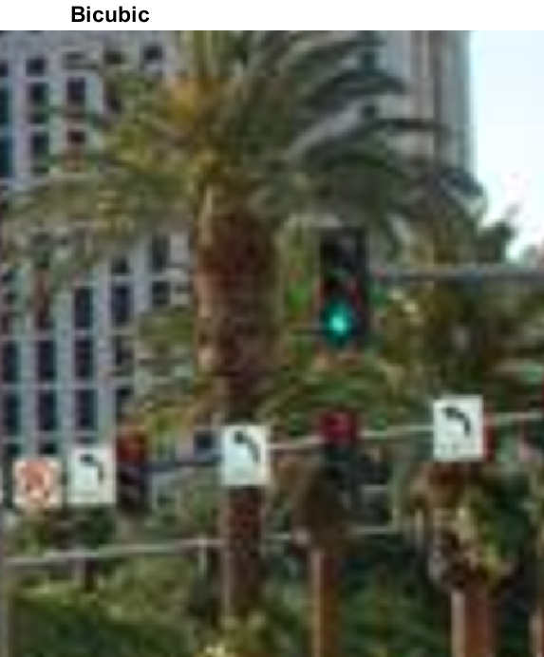

# Contrast table of subjective evaluation with different interpolation methods

|  |  |  |  |  |
| --- | --- | --- | --- | --- |
| Interpolation Type | Subjective Feelings | Image Contour | Overall Evaluation | Processing Time (seconds) |
| Nearest_ Neighbor | Mosaic, Lost info | Not clear, Stairway on zooming | Worst | 5 |
| Bilinear | Blur, not sharp | Not clear, Washed out figures, | Poor | 8 |
| Bicubic | Fuzzy, sharper | Improved Edges | Better | 10 |

# Interpolation Conclusion

# Nearest neighbor interpolation algorithm is the most simple and fast algorithm. It has the advantages of fast speed, but it can bring significant distortion and it will appear mosaic and saw tooth phenomenon.

# Bilinear interpolation method is more complex than the nearest neighbor method, and so it has larger calculation. It has no gray discontinuity defects and has satisfactory results. This method has a low pass filtering property, so that the high frequency component is faded and the image contour has some degree of fuzzy. As the results of bilinear interpolation algorithm is continuous, so the visual effect is better than the nearest point interpolation algorithm, but the operation speed is slightly slower. Because of this, if someone pays more attention to speed and good visual effect, this is a good compromise.

# Bicubic interpolation algorithm can get relatively clear picture quality, but it needs larger amount of calculation. This algorithm now is most commonly used in many image processing software such as Photoshop, After Effects, Avid and Final Cut Pro etc.